Short Biography of Hiroshi Iwai

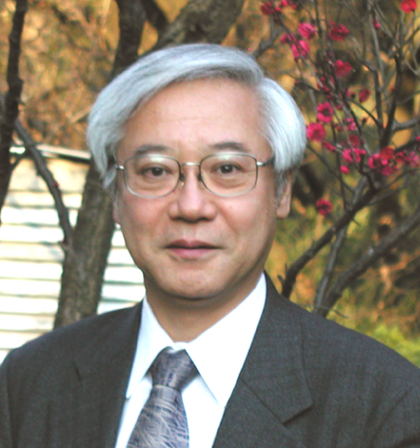
Hiroshi Iwai is a professor in Frontier Collaborative Research Center and also in Interdisciplinary Graduate School of Science and Engineering, Tokyo Institute of Technology. He received the B.E. and Ph.D. degrees in electrical engineering from the University of Tokyo.

He worked in the research and development of integrated circuit technology for more than 25 years in Toshiba, and developed several generations of high density static RAM's, dynamic RAM's and logic and communication LSI's by newly-developing NMOS, dual gate CMOS, high-speed bipolar, Bi-CMOS, and RF CMOS technologies. He has also been engaged in research on device physics, process technologies, and T-CAD related to small-geometry MOSFETs and high speed bipolar transistors. He has authored and coauthored more than 200 papers.

In 1999, he retired from Toshiba and was invited to join Tokyo Institute of Technology as a professor to study Nano-CMOS device technologies. He has taken a leadership in the research of Nano-CMOS technologies as the leader of a Nano CMOS project composed of 7 universities, 1 national laboratory, and 2 companies, sponsored by Ministry of Education, Culture, Sports, Science and Technology, Japan, and has achieved many new results for the progress of the Nano-CMOS technologies.

His current research fields are for Nano-CMOS technology in general, including those of high–k and metal gate stack, plasma doping for ultra-shallow junctions, Ni salicide, Metal S/D, RF CMOS modeling, 3D MOSFET analysis, Ge transister, and Chip Embedded and Chip Technology.

He has served on many committees of conferences and editors of journals, as well as evaluation, advisory, and award committees of public organizations; for example, the President of the IEEE EDS, the General Chair of the IEEE BCTM, and the Editor-in-chief of IEICE Trans. on Electronics.

His awards include Nagoya Mayor Award (1968), Local Commendation for Invention from Japan Institute of Invention and Innovation (1990, 2005), Grand Prize of Nikkei BP Technology Awards (1994), IEEE EDS Paul Rappaport Award (1994), IEICE ES Electronics Award (1998), IEEE EDS J.J.Ebers Award (2001), and JSAP Award for the best paper (2002).

Dr. Iwai is, a fellow of IEEE, a member of Electrochemical Society, a member of the Japan Society Applied Physics, a member of the Institute of Electronics, Information and Communication Engineers of Japan, and a member of the Institute of Electrical Engineers of Japan.

